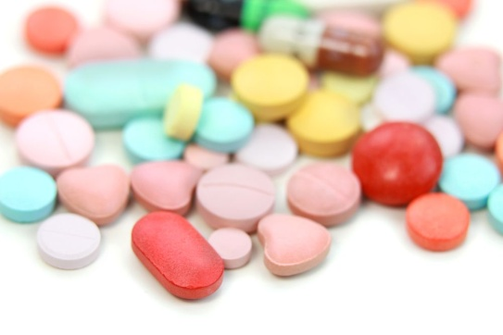

ANTIBIOTIC & Other MEDICATION SHORTAGES

There are currently over 44 antibiotic shortages. The list below is the most common antibiotics which Dr. Hayford prescribes. If the antibiotic written for your child is not available at your pharmacy, specially ask which they have in stock. The pharmacy may also be able to tell you the closest pharmacy available in your area if they do not have stock. If there is not stock at your local pharmacy, please call other pharmacies to check before calling the office for a change.

If there is a change in medication or pharmacy, Dr. Hayford will need to review and determine which medication would be best prescribed. Since Dr. Hayford is with patients during the day, the refill might not be called in after clinic hours are over.
​
- Amoxicillin
- Augmentin
- Cephalexin (brand name is Keflex)
- Cefdinir
- Azithromycin

​

Other Medications Shortages

Millions of people who use certain common medicines and prescriptions may be finding it more difficult to get their normal prescriptions dispensed. This comes after pharmacies have all reported shortages of many different drugs. If your local pharmacy doesn't have your medication, you can try other pharmacies to find the medication before the prescription has to be changed to an alternative product. It's unlikely that medicines shortages are going to be resolved anytime soon. As such, it's important you speak with your pharmacist or doctor about any concerns you have, how shortages affect your medication supply, and what course of action you may need to take. It's important you don't use an alternative product without speaking to your pharmacist or doctor to avoid adverse side effects.

